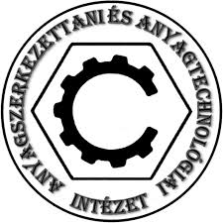
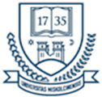
INTERNATIONAL WELDING ENGINEER

POSTGRADUATE PROGRAMME

The Faculty of Mechanical Engineering and Informatics of the University of Miskolc (Hungary) will begin the next academic year of the International Welding Engineer postgraduate course in September 2025. The course will be comprised of 3 semesters, culminating in a degree thesis and a final examination, with successful candidates receiving the Diploma of International Welding Engineer. The Welding Engineer course curriculum and syllabus fully meets the requirements of the IIW (International Institute of Welding) and EWF (European Welding Federation), so participants will be awarded with

International/European Welding Engineer Diploma (IWE/EWE)

The aim of the Welding Engineer course is to provide an in-depth professional, scientific and practical knowledge of welding and related processes in the following areas:
- materials science (materials science and weldability, materials testing)
- welding processes and equipment,
- design of welded structures,
- manufacture and quality assurance of welded structures.
The course is self-financed, the tuition fee is 575 000 HUF/person (approx. 1400 EUR/person) per semester, which includes the fees for the training, the practical work, and the consultation of the degree thesis, as well as the delivery of digital learning materials. The fee for the final examination is expected to be 250 000 HUF/person (approx. 610 EUR).
Participants in the training will attend lectures on-line and practical classes in person. The practical courses will be organized for approximately one whole week in the mid of the first and the second semester.
Eligibility criteria:
- degree in mechanical engineering (BSc, MSc, MSc) or other technical field related to mechanical engineering;
- and two years of work experience.
In case of MSc graduation in mechanical engineering it is possible to start the course without industrial experience.
Further information, including the detailed curriculum and application form are available here:
http://www.gepesz.uni-miskolc.hu/POSTGRADUATE_PROGRAMME
To apply, please send the application form, the CV highlighting the work experience and a copy of your degree (diploma) certificate:
Dr. Raghawendra Sisodia IWE/EWE
e-mail: raghawendra.sisodia@uni-miskolc.hu
tel.: +36-70/352-0357
Application deadline: 15th June 2025

